SIMATS ENGINEERING (SAVEETHA SCHOOL OF ENGINEERING)
Department of Computer Science and Engineering
CO1 ASSESSMENT TOOL 1 – Case Study Analysis
Course Code: | CSA10 / CSA1063 | Course Title: | Software Engineering
CO Assessed: | CO1 | Assessment: | Assessment Tool 1 – Case Study Analysis
Weightage: | 20% | Total Marks: | 25
CO1 Statement: | Apply advanced methodologies and agile project management techniques to manage software projects effectively
Student Name: | P. Lohith Krishna | Reg. No.: | 192325122
Date: | 22/07/2026 | Duration: | 60 minutes

Code of Conduct
I _________________P. Lohith Krishna_________ (Name / Reg No) certify that this submission is my original work and that I have adhered to the guidelines specified for this assessment. I understand that any violation of academic integrity rules will result in disciplinary action.
Signature of the Student: __P .Lohith Krishna______________________

Annexure A – Case Study Analysis
Instructions to Students:
Each student will be allotted one problem statement. Analyze the assigned problem systematically by following the steps given below. Your report should demonstrate your understanding of software engineering concepts and your ability to design an appropriate software solution.
Based on your allotted problem statement, prepare a report by answering the following questions:
- Understand the Problem Statement
  - Explain the problem in your own words.
The Travel Expense Tracking and Budget Management Application addresses the challenge of users struggling to track expenses during trips and manage budgets effectively. The current process is reactive, fragmented, and inefficient, highlighting the need for a streamlined solution. The application aims to simplify expense tracking and budget management, providing real-time tracking, alerts, and automated reporting.
- Manual expense reporting is time-consuming and prone to errors, leading to overspending and lack of financial insights.
- Users often forget to save receipts or track small expenses, resulting in missed reimbursements.
- Reimbursement processes are delayed due to incomplete or incorrect reports, causing frustration.
- The lack of real-time tracking and alerts leads to budget mismanagement, making it hard for users to stay within budget.
- Users face issues with managing multiple currencies and conversion rates during international trips.
- There's a lack of visibility into spending patterns, making it hard to optimize budgets.
- The solution will integrate with financial tools for easier reconciliation.
- Users will benefit from improved accuracy and reduced reimbursement delays.
- The application will enhance financial visibility and control.
- It'll make managing travel expenses more efficient and proactive.

  - Identify the objectives of the proposed system.
The Travel Expense Tracking and Budget Management Application aims to simplify expense tracking and budget management for users. It provides a user-friendly interface for logging expenses during trips and offers real-time budget tracking. The application enhances overall efficiency in managing travel expenses and improves financial visibility and control.
- Allows users to easily log expenses during trips
- Provides real-time budget tracking, keeping users updated on their spending
- Alerts for overspending help users stay within budget limits
- Generates expense reports automatically for reimbursement, reducing manual effort
- Users get notifications for incomplete reports or missing receipts
- Offers insights into spending patterns, enabling better financial decisions
- Supports multiple currencies and conversion rates for international trips
- Users can set and manage budgets per trip or category as needed
- System integrates with financial tools for easier reconciliation
- Automates expense tracking, saving users time
- Reduces errors and discrepancies in expense reporting
- Accessible on web and mobile for user convenience
- The application enhances overall efficiency in managing travel expense
  - State the scope of the problem.
The scope of the Travel Expense Tracking and Budget Management Application includes targeting employees, travelers, freelancers, and small businesses who need to manage travel expenses. The application is designed for simplicity and effectiveness in managing travel expenses, focusing on ease of use for non-accountants and non-finance users.
- Focuses on travel-related expenses like flights, hotels, meals, and transportation
- Supports multiple currencies and payment methods for international use
- Includes basic analytics for spending insights and budget tracking
- Integrates with common financial tools for easier reconciliation and reporting
- Ensures data privacy and security with robust measures
- Available on mobile and web platforms for user convenience
- Users can log expenses, track budgets, and get reimbursements through the app
- Won't cover investments, loans, or complex accounting features
- Helps users save time and reduce errors in expense tracking
- Scalable for growing user needs
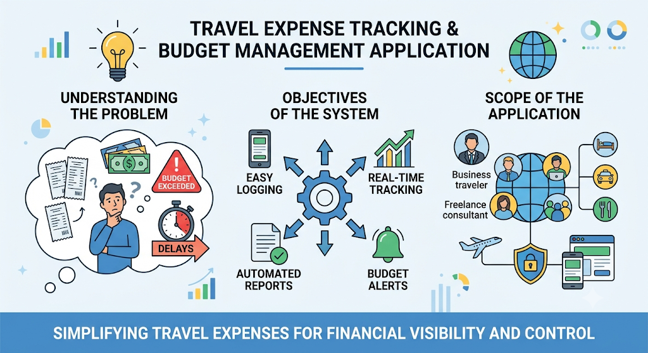
- Provides a straightforward solution for managing travel budgets and expenses

- Identify Key Stakeholders and Challenges
  - Identify all the stakeholders involved in the system.
Travel Expense Tracking and Budget Management Application relies on four main stakeholder groups: users, finance teams, app developers, and data analysts. Users log expenses and submit reports, while finance teams approve reimbursements and enforce compliance. Developers focus on app maintenance and security, as analysts evaluate spending patterns for better decision-making. To ensure effectiveness, all parties collaborate continuously through regular meetings and structured feedback loops. Together, they create a streamlined system that improves overall efficiency and financial control across the organization.
- Users (Travelers / Employees):
  - Log daily expenses and submit reports.
  - Keep track of budgets to ensure spend stays within set limits.
  - Provide accurate transaction data and user feedback for app improvements.
- Finance / Admin Teams:
  - Review and approve submitted expense reports.
  - Process reimbursements and manage overall organizational budgets.
  - Ensure app usage and reported expenses comply with company policies.
- App Developers:
  - Develop, maintain, and update the application.
  - Ensure the platform is secure, reliable, and user-friendly.
  - Implement changes and feature updates based on user feedback.
- Data Analysts:
  - Analyze user spending patterns across trips and departments.
  - Provide actionable insights and reports to the finance team.
  - Support informed, data-driven financial decision-making.
- Collaboration & Workflow:
  - Stakeholders meet regularly to review progress and make necessary adjustments.
  - Information flows continuously between users, developers, analysts, and finance teams to keep the system efficient.
  - Explain the roles and responsibilities of each stakeholder.
Users log expenses, upload receipts, and manage budgets, while finance teams handle reviews, policy compliance, and reimbursements. Developers maintain app functionality, security, and updates, as analysts provide spending insights to support financial decisions. Every stakeholder plays a clearly defined role in maintaining data accuracy and proper system usage across the organization. By collaborating effectively, all parties ensure the application remains user-friendly, compliant, and optimized for organizational needs. Together, these efforts create a highly efficient, reliable, and effective travel expense management workflow.

- Users (Travelers / Employees):
  - Log daily travel expenses and submit reports on time.
  - Monitor trip spending to keep costs within assigned budget limits.
  - Upload clear receipts and provide detailed information for every transaction.
  - Ensure all submitted financial data is accurate and truthful.
- Finance / Admin Teams:
  - Review, audit, and approve submitted expense reports.
  - Oversee budget allocations and process employee reimbursements promptly.
  - Ensure every reported expense fully complies with company policies and procedures.
- App Developers:
  - Build and maintain core application functionality, security, and performance.
  - Deliver continuous user support and refine the UI to keep it user-friendly.
  - Implement system enhancements and updates based on user needs.
- Data Analysts:
  - Analyze spending patterns across trips, categories, and departments.
  - Prepare detailed reports and recommendations for the finance team.
  - Deliver insights that help leadership make informed financial decisions.
- Shared Stakeholder Responsibilities:
  - Ensure the application is used correctly according to designated roles.
  - Maintain precise data accuracy across all logging and reporting processes.
  - Collaborate continuously to ensure the application remains efficient and effective.
  - Discuss the major challenges and issues faced by the stakeholders.
Stakeholders encounter diverse challenges ranging from daily operational issues to complex technical requirements. Users struggle with logging expenses, categorization, managing foreign currencies, staying on budget, and resolving discrepancies. Finance teams face bottlenecks in policy compliance, efficient report processing, and managing approval workflows. Meanwhile, developers must guarantee robust app security and seamless integration with external financial systems. Data analysts are hampered when attempting to derive meaningful insights from incomplete or inaccurate inputs. Overcoming these hurdles requires close collaboration, accurate data entry, and continuous feedback to build an efficient, user-friendly tool.
- User Challenges:
  - Forgetting to log transactions or struggling to choose correct expense categories.
  - Navigating multi-currency conversions and foreign exchange complexity.
  - Keeping spending strictly within assigned budget limits during trips.
  - Resolving reporting discrepancies between receipts and logged figures.
- Finance Team Challenges:
  - Processing high volumes of expense reports quickly without creating approval backlogs.
  - Enforcing company policies consistently across all submitted reports.
  - Managing ongoing budget tracking and multi-tier approval workflows effectively.
- App Developer Challenges:
  - Ensuring top-level data security and user privacy across web and mobile platforms.
  - Integrating the application smoothly with diverse third-party financial systems.
  - Creating an intuitive design that remains powerful yet accessible to non-accountants.
- Data Analyst Challenges:
  - Extracting clear spending trends when raw user inputs are incomplete or inaccurate.
  - Generating reliable, actionable insights to help optimize future corporate budgets.
- Collaborative Requirements:
  - Providing active user feedback and suggestions to address emerging issues.
  - Working together across departments to ensure high data quality and system effectiveness.
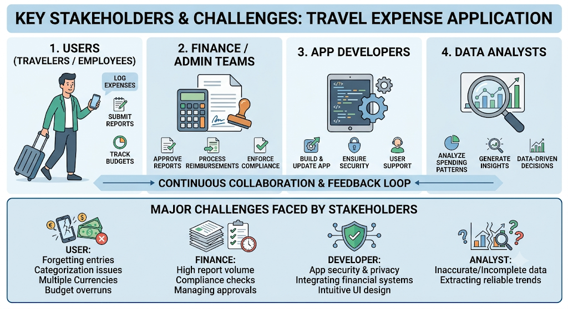

- Analyze the Current Approach
  - Describe the existing system or current process.
The current travel expense and budget management process relies on fragmented, manual methods such as paper receipts and personal spreadsheets. Because employees log costs retroactively without centralized tools, reports are frequently delayed, incomplete, or missing mandatory receipts. Finance teams spend excessive time manually auditing entries, leading to reimbursement backlogs and poor policy compliance. Without real-time tracking or automated alerts, budget management remains entirely reactive, making overspending a persistent issue. These inefficient procedures create frustration for employees waiting on payouts and hinder financial visibility across the organization. Consequently, transitioning to an automated, centralized platform is essential to restore accuracy, efficiency, and proactive budget control.

- Manual & Decentralized Operations:
  - Relies heavily on paper receipts, physical documents, and personal memory.
  - Lacks a centralized system, forcing employees to manage budgets through independent spreadsheets.
  - Creates an inefficient, tedious workflow that hurts overall employee productivity.
- Employee & Reporting Pain Points:
  - Post-trip reporting leads to delayed submissions, missing receipts, and incomplete information.
  - Manual expense categorization and tracking are time-consuming and error-prone.
  - Employees struggle to stay within budget limits due to a lack of real-time visibility.
- Finance Team & Operational Bottlenecks:
  - Manual review and approval workflows result in reimbursement delays and employee frustration.
  - Ensuring compliance and policy adherence across all submissions is difficult and labor-intensive.
  - Reporting and data analytics require extensive manual effort to reconcile.
- Systemic Weaknesses:
  - Reactive budget management discovers overspending only after expenses are incurred.
  - Absence of real-time alerts prevents timely intervention before budgets are exceeded.
  - High vulnerability to calculation errors, discrepancies, and unallocated costs.

  - Identify its strengths and limitations.
The current manual expense tracking process relies on low-upfront-cost tools and familiar routines, giving employees the flexibility to track costs using personal methods. Finance teams are accustomed to manual approval workflows, making the legacy approach simple to operate on a basic level. However, these minor strengths are heavily overshadowed by significant operational limitations, such as human error, poor security, and time-consuming workflows. The absence of real-time tracking, multi-currency support, and system integrations leaves budget management weak and reactive. Relying entirely on manual effort hinders corporate visibility into spending trends and frequently causes budget overruns. Ultimately, the system’s severe constraints demonstrate an urgent need for an automated, modern solution.

- Key Strengths (Legacy Benefits):
  - Simplicity & Familiarity: Employees and finance teams are comfortable with established manual review and approval routines.
  - Low Upfront Cost: Leverages existing basic tools and paper processes without requiring immediate software investments.
  - Flexibility: Allows employees to temporarily track costs using personal spreadsheets or preferred basic tools.
- Major Limitations (Systemic Drawbacks):
  - Inaccurate & Inefficient: Highly prone to manual calculation errors, lost paper receipts, and tedious, time-consuming data entry.
  - Lack of Automation & Integration: Operates without modern software integrations, automated workflows, or real-time tracking capabilities.
  - Weak Budget Control: Offers no proactive alerts or spending insights, making budget overruns common and difficult to prevent.
  - Global & Technical Shortfalls: Fails to support multiple currencies, complex trip itineraries, or robust data security and privacy measures.
  - Delayed Decision-Making: Delivers limited, outdated reporting that hampers leadership’s ability to analyze spending trends effectively.

  - Analyze the problems or gaps that need to be addressed.
The existing travel expense system is severely constrained by manual processes, lack of automation, and frequent calculation errors. A critical operational gap exists due to the absence of real-time tracking, multi-currency support, and seamless integration with corporate financial tools. Reporting remains slow and limited, offering no proactive visibility into employee spending patterns or potential budget overruns. Furthermore, paper-based handling creates security risks, while manual expense categorization places an unnecessary burden on both travelers and finance teams. These combined shortfalls force management into a reactive state rather than a proactive financial strategy. Ultimately, bridging these gaps requires an automated, streamlined solution that ensures policy compliance and real-time budget management.

- Core Operational Inefficiencies:
  - High susceptibility to manual errors, tedious data entry, and lost physical receipts.
  - Lack of system automation, forcing finance teams into labor-intensive compliance and policy enforcement.
  - Tedious expense categorization that creates friction for reporting employees.
- Critical System Gaps:
  - No Real-Time Tracking: Lack of live expense monitoring and automated budget alerts leads to frequent overspending.
  - Limited Global Support: Inability to handle multiple foreign currencies or diverse payment methods for international trips.
  - Security Vulnerabilities: Paper-based receipt storage poses significant data privacy and security concerns.
- Reporting & Financial Oversight:
  - Analytics are delayed and basic, failing to deliver actionable insights into organizational spending patterns.
  - Disconnected architecture that lacks integration with modern accounting and ERP tools.
  - Management operates reactively rather than proactively managing travel budgets.
- Key Requirements for the New Solution:
  - Full automation of receipt logging, categorization, and reimbursement workflows.
  - Real-time budget alerts alongside multi-currency and multi-payment support.
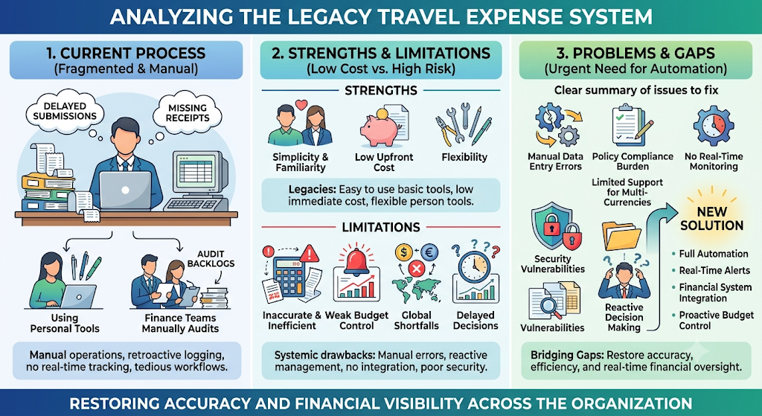
  - Seamless integration with external financial tools to ensure end-to-end data accuracy and efficiency.

4.Propose a Suitable Solution Using Software Engineering Principles
  - Design a software-based solution for the given problem.
The proposed Travel Expense Tracking and Budget Management System is a comprehensive web and mobile solution designed to fully automate expense logging, receipt capture, and financial reporting. By offering real-time budget tracking, auto-categorization, and instant discrepancy flagging, the system drastically cuts down manual effort and human error. Finance teams gain an efficient platform to review, audit, and process reimbursements without traditional administrative bottlenecks. Live analytics and customizable alert thresholds empower both travelers and administrators to manage trip budgets proactively rather than reactively. Built with multi-currency support, seamless financial software integration, and robust data security, the platform ensures complete regulatory compliance. Ultimately, this scalable and reliable application delivers greater financial control, transparency, and operational productivity across the organization.

- Automated Expense & Receipt Management:
  - Enables swift receipt uploading with auto-categorization of expenses to minimize manual entry.
  - Automatically flags transaction discrepancies and missing details to maintain high data accuracy.
  - Generates automated expense reports to streamline submissions and eliminate paperwork.
- Real-Time Budget Control & Alerts:
  - Tracks trip spending in real time, giving users immediate visibility into remaining balances.
  - Triggers automated alerts when approaching budget limits or detecting unusual transactions.
  - Shifts budget management from a reactive post-trip process to a proactive operational approach.
- Finance Team & Operational Efficiency:
  - Streamlines review, approval, and reimbursement workflows to significantly shorten payout cycles.
  - Provides live analytics and spending pattern insights to support strategic financial planning.
  - Ensures full compliance with corporate policies and financial regulatory standards.
- Technical & Global Architecture:
  - Delivers a user-friendly, responsive experience across both web and mobile platforms.
  - Supports multiple currencies and payment methods for seamless international travel.
  - Features secure, scalable infrastructure with automated regular data backups and customizable organizational settings.
  - Describe the major functional modules of the proposed system.
The system architecture comprises key functional modules designed to deliver an end-to-end expense management experience. Core components include User Management, Expense Tracking, Budget Management, Reporting and Analytics, Finance Management, and Notifications. Role-based dashboards provide tailored views and permissions for travelers, finance teams, and administrators. Built-in APIs enable smooth integration with external software tools, while seamless data flow across all modules eliminates information silos. Every module is thoroughly tested, scalable for future upgrades, and regularly maintained to guarantee high reliability. Together, these integrated modules provide an easy-to-use, efficient, and robust platform for organizational finance.
- User Management Module:
  - Handles user registration, login authentication, and profile settings.
  - Manages role-based permissions and controls secure data access across different user groups.
- Expense Tracking & Budget Management Modules:
  - Expense Tracking: Allows users to log transactions, upload receipts, and apply auto-categorization.
  - Budget Management: Enables setting custom trip/category budgets and tracking expenditures in real time with spending alerts.
- Finance & Analytics Modules:
  - Finance Management: Streamlines report reviews, multi-tier approvals, and reimbursement processing.
  - Reporting & Analytics: Generates detailed expense reports and provides data-driven spending insights.
- System Infrastructure & Capabilities:
  - Notifications: Sends real-time alerts for budget thresholds, status updates, and unusual transactions.
  - Role-Based Dashboards: Offers clean, intuitive interfaces customized for both regular users and finance admins.
  - Integration & Scalability: Features APIs for external tool connectivity and a scalable architecture tested for ongoing reliability and maintenance.
  - Identify the functional and non-functional requirements.
The application is defined by clear functional and non-functional requirements to ensure it meets core organizational goals. Functionally, the system automates expense logging, receipt uploads, smart categorization, discrepancy flagging, and multi-currency conversions. It empowers finance teams with streamlined approval workflows, live analytics, and real-time budget threshold alerts. Non-functionally, the platform prioritizes robust security, data privacy, high scalability, and strict regulatory compliance. Performance is optimized for fast processing speeds, accompanied by automated data backups and role-based access controls. Together, these combined requirements guarantee an accessible, highly reliable, and enterprise-ready travel management tool.
- Functional Requirements (System Features):
  - Expense Capture & Auditing: Log daily expenses, upload receipts, auto-categorize transactions, and automatically flag discrepancies.
  - Finance & Approvals: Enable finance teams to efficiently review, audit, and approve reimbursement reports.
  - Analytics & Notifications: Deliver real-time spending insights and push alerts for budget limits or unusual transactions.
  - Global Integration: Support multiple international currencies and integrate seamlessly with external financial tools.
- Non-Functional Requirements (System Quality & Performance):
  - Security & Compliance: Ensure data privacy via strong encryption, robust authentication/authorization, and full compliance with financial regulations.
  - Performance & Speed: Optimize system architecture for fast processing speeds and responsive user interactions.
  - Reliability & Scalability: Maintain system stability, execute regular automated data backups, and support growth in user volume.
  - Usability & Accessibility: Design an intuitive, user-friendly interface rigorously tested for accessibility across web and mobile platforms.
  - Explain how software engineering principles such as modularity, scalability, maintainability, reliability, usability, and security are incorporated into your solution.
The application incorporates core software engineering principles to deliver an effective, high-performing, and resilient solution. A modular architecture with loose coupling ensures the system remains maintainable, scalable, and adaptable to future organizational changes. High performance and speed are complemented by robust security measures, including strong encryption, authentication, and authorization. Built-in error handling, automated backups, and thorough testing guarantee system reliability and seamless operational continuity. APIs facilitate external integrations, while proactive performance monitoring and continuous user feedback loops drive iterative updates. Ultimately, these engineering standards ensure the platform meets evolving business needs while delivering exceptional usability and data safety.
- Architecture & Scalability:
  - Modularity & Loose Coupling: Built with independent modules for distinct functions to simplify maintenance and code updates.
  - Scalability & Adaptability: Designed to handle increasing user volume, data growth, and future system enhancements effortlessly.
  - API & Integrations: Uses standardized APIs to enable seamless data exchange and connectivity with external tools.
- Reliability, Security & Performance:
  - Robust Security: Protects user data through strict authentication, authorization controls, and data encryption.
  - High Reliability: Implements comprehensive error handling mechanisms, automated data backups, and regular performance monitoring.
  - Speed & Performance: Optimized for fast processing speeds and consistent responsiveness under heavy operational loads.
- Quality Assurance & Lifecycle Management:
  - Thorough Testing: Undergoes rigorous testing phases to guarantee functional accuracy, system stability, and smooth usability.
  - Maintainability: Supported by well-documented code bases to make ongoing maintenance and troubleshooting straightforward.
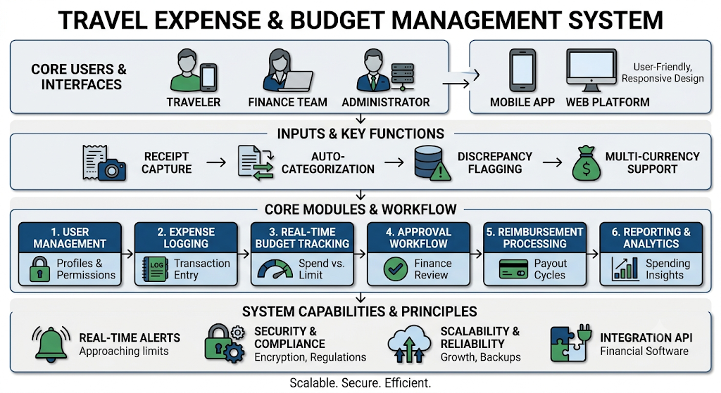
  - Continuous Improvement: Driven by real-time user feedback, regular software updates, and proactive feature enhancements.

5. Justify the Chosen Methodology/Framework
  - Select an appropriate Software Development Life Cycle (SDLC) model or software development framework (e.g., Agile, Scrum, Waterfall, Spiral, DevOps).
The Travel Expense Tracking and Budget Management System will be developed using the Agile methodology under the Scrum framework. This iterative and incremental approach accommodates evolving requirements while fostering strong team collaboration, transparency, and continuous delivery. Development is organized into 2- to 4-week sprints to maintain focus, deliver functional software early, and incorporate regular stakeholder feedback. Key roles—including the Product Owner, Scrum Master, and cross-functional Scrum team—work together to prioritize backlog items and resolve technical impediments. Continuous feedback through daily stand-ups, sprint reviews, and retrospectives allows the team to adapt quickly to operational changes. Ultimately, this framework ensures early value delivery, high software quality, clear documentation, and sustained alignment with organizational goals.
- Agile Strategy & Sprint Structure:
  - Adopt an iterative, incremental approach tailored for evolving system requirements and ongoing flexibility.
  - Execute development in focused 2- to 4-week sprints to accelerate feature delivery and testing.
  - Translate user requirements into prioritized User Stories to guide software features and releases.
- Scrum Roles & Collaboration:
  - Product Owner: Prioritizes the product backlog to maximize business value and align features with user needs.
  - Scrum Master: Facilitates daily workflows, enforces Scrum principles, and removes operational impediments.
  - Scrum Team: Comprises developers, software testers, and stakeholders working closely together to build and verify features.
- Core Ceremonies & Quality Assurance:
  - Daily Stand-ups: Maintain team transparency, monitor daily progress, and resolve emerging issues quickly.
  - Sprint Reviews & Retrospectives: Evaluate completed software at the end of each sprint to drive continuous process improvements.
  - Documentation & Continuous Improvement: Maintain clear software documentation for reference while adapting iteratively to changes.
  - Justify why the selected methodology/framework is suitable for the proposed system.
The Travel Expense Tracking and Budget Management System will be developed using the Agile methodology under the Scrum framework to support evolving requirements. By dividing work into focused 2- to 4-week sprints, the team ensures continuous software delivery, rapid issue resolution, and regular stakeholder collaboration. Roles like the Product Owner and Scrum Master drive backlog prioritization and process efficiency to maintain consistent project momentum.
- Agile Strategy & Sprint Structure:
  - Adopt an iterative approach tailored for changing requirements and ongoing flexibility.
  - Execute development in 2- to 4-week sprints to accelerate feature delivery and testing.
  - Translate user requirements into prioritized User Stories to guide software features.
- Scrum Roles & Collaboration:
  - Product Owner: Prioritizes the product backlog to maximize business value.
  - Scrum Master: Facilitates daily workflows and removes technical impediments.
  - Scrum Team: Comprises developers, testers, and stakeholders working collaboratively.
- Core Ceremonies & Quality Assurance:
  - Daily Stand-ups: Maintain transparency, monitor progress, and resolve emerging issues.
  - Sprint Reviews & Retrospectives: Evaluate completed software to drive continuous improvement.
  - Documentation & Adaptability: Maintain clear documentation while adapting iteratively to changes
Agile with Scrum provides the ideal balance of flexibility and structure necessary for managing complex, evolving travel management software. Iterative sprints allow the team to release working features early, gathering continuous stakeholder feedback through live demos and reviews. This proactive approach ensures the final application stays aligned with real-world user needs and organizational travel policies.
- Flexibility & Adaptability:
  - Accommodates shifting travel policies, integrations, and user needs without disrupting progress.
  - Breaks down complex features into manageable development and testing cycles.
  - Responds swiftly to user feedback and changing business priorities.
- Continuous Delivery & Stakeholder Engagement:
  - Delivers functional software incrementally to provide early value.
  - Keeps stakeholders actively involved through regular sprint demos and reviews.
  - Guarantees the final product aligns directly with organizational workflows.
- Structured Execution & Alignment:
  - Product Owner: Curates backlog items to ensure alignment with business goals.
  - Scrum Master: Enforces framework discipline and removes operational bottlenecks.
  - Daily Stand-ups: Promote team transparency and support fast issue resolution.
  - Explain how it supports successful project development and maintenance.
Agile with Scrum supports successful development and maintenance through its structured, iterative approach that keeps teams focused on core goals. Regular sprint cycles ensure continuous software delivery, allowing for early risk management and swift issue resolution. Strong collaboration and daily stand-ups maintain complete transparency, while the Product Owner prioritizes features to deliver maximum business value. Built-in reviews and retrospectives drive ongoing quality improvements, making future system maintenance simple through modular development. By delivering working software regularly, the framework keeps stakeholders engaged and ensures the project consistently meets organizational objectives.
- Iterative Development & Maintenance:
  - Drives focused development and testing through predictable sprint cycles.
  - Simplifies long-term system maintenance through modular, step-by-step feature builds.
  - Enables swift adaptation to changing requirements and emerging risks.
- Team Collaboration & Transparency:
  - Fosters team ownership, accountability, and alignment across all project stages.
  - Maintains high visibility and fast issue resolution through daily stand-up meetings.
  - Clear documentation is continuously maintained for team reference and future clarity.
- Value Delivery & Quality Assurance:
  - Product Owner: Prioritizes features to guarantee maximum return on business value.
  - Sprint Reviews & Retrospectives: Evaluate performance after each sprint to refine processes and software quality.
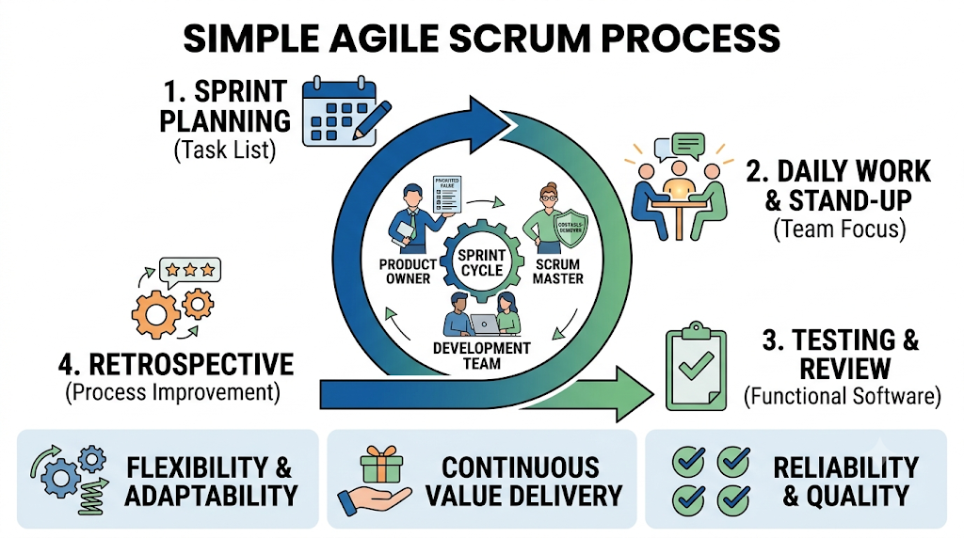
  - Stakeholder Engagement: Delivers functional, working software regularly to ensure continuous alignment with user expectations.

6.Discuss Expected Outcomes and Limitations
  - Describe the expected benefits of the proposed solution.
The proposed Travel Expense Tracking System delivers end-to-end automation, real-time spending control, and multi-currency support on both web and mobile platforms. By connecting directly with existing financial tools, it streamlines workflows, safeguards data, and scales effortlessly with organizational growth.
- Automated Logging & Processing: Eliminates manual data entry errors and speeds up employee reimbursements.
- Real-Time Budget Control: Provides live expense updates alongside proactive alerts for overspending or unusual transactions.
- Mobile & Multi-Currency Support: Enables flexible expense logging on-the-go with seamless conversion for international travel.
- Smart Financial Insights: Analyzes spending patterns to help finance teams make better data-driven decisions.
- Seamless Tool Integration: Connects directly with organizational accounting software for quick, painless reconciliation.
- Policy Compliance: Automatically enforces company expense policies, reducing non-compliant spending.
- Data Security & Scalability: Protects sensitive financial data with secure backups while supporting business expansion.
- Time & Cost Efficiency: Boosts overall productivity and delivers measurable cost savings through automated analytics.
  - Explain how the solution addresses the identified challenges.
The proposed expense management solution directly targets traditional pain points by replacing tedious manual tasks with modern, automated workflows. It offers a user-friendly mobile experience that enables employees to log transactions anytime, anywhere, with support for multiple currencies. Proactive tracking and instant alerts give both travelers and finance teams full control over budgets before overspending occurs. Built-in compliance checks and integration with existing accounting tools significantly speed up the reimbursement cycle. Strong security protocols safeguard sensitive financial data while automated analytics surface clear spending trends. Ultimately, this comprehensive approach minimizes errors, elevates user satisfaction, and streamlines organizational expense management.

- Automated Logging & Categorization: Captures expense details accurately to eliminate manual data entry errors.
- Proactive Budget Alerts: Sends instant notifications for overspending, missing receipts, or incomplete reports.
- Streamlined Reimbursements: Speeds up finance team review processes, significantly reducing payment delays.
- System Integration: Syncs seamlessly with existing financial tools for effortless account reconciliation.
- Global Travel Support: Handles multiple currencies and payment methods for hassle-free international trips.
- Policy Compliance & Security: Enforces corporate expense regulations automatically while protecting sensitive data.
- Actionable Analytics: Generates clear reports on spending patterns to empower smarter financial decision-making.
  - Discuss potential risks, implementation challenges, and limitations.
This project involves several potential risks and implementation hurdles that require careful planning and ongoing management. Transitioning users from familiar manual habits to an automated platform can cause initial friction and training challenges. Additionally, technical complexities—such as secure data migration, multi-currency processing, and multi-tool integration—demand robust design and execution. Mobile app performance, internet dependency, and system scalability must also be continually managed to prevent service disruptions. Security breaches and shifting regulatory compliance present ongoing operational threats if left unmonitored. Through thorough testing, active user feedback, and dedicated technical support, these risks can be effectively mitigated.
- User Adoption & Resistance: Transitioning employees from legacy manual workflows to automation requires dedicated training to overcome user pushback and misuse.
- Data Security & Privacy: Safeguarding sensitive financial information demands strict protocol execution, routine updates, and active threat protection.
- Technical Integration & Migration: Merging complex data from old systems and connecting seamlessly with existing financial tools present technical hurdles.
- System Scalability & Performance: Improper architectural design could cause system lag or failures when handling large volumes of data or expanding user bases.
- Mobile & Currency Complexity: Supporting offline mobile functionality and accurately processing multiple global currencies require meticulous testing.
- Regulatory & Compliance Changes: Finance teams must ensure the application stays updated with evolving regional tax policies and company rules.
- Operational Dependencies: Real-time updates remain dependent on reliable internet connectivity, requiring ongoing maintenance and user support.

  - Suggest possible future enhancements.
Implementing future enhancements will elevate the Travel Expense Tracking System into an intelligent, end-to-end travel management hub. Integrating advanced technologies like artificial intelligence, biometric security, and corporate card sync will automate manual entry while tightening financial controls. Expanding integrations with travel booking platforms and third-party APIs further unifies the trip lifecycle for users and finance teams. Additionally, features like offline accessibility and continuous feedback loops ensure long-term usability and adaptation. Ultimately, these roadmap features focus on delivering maximum user convenience, smarter insights, and automated compliance.

- AI-Driven Automation: Smart expense categorization, predictive budgeting, and anomaly detection to flag fraud or unusual spending.
- Corporate Card & Booking Sync: Direct integration with corporate credit cards for auto-logging transactions and travel booking platforms for unified trip management.
- Mobile & Usability Upgrades: Receipt scanning (OCR), voice input, offline mode capabilities, and biometric authentication (fingerprint/Face ID).
- Advanced Analytics & Custom Reporting: Customizable dashboards, tailored expense reports, and personalized budget recommendations.
- Streamlined Workflows & Audits: Tiered approval workflows for various expense types and automated auditing tools for policy compliance.
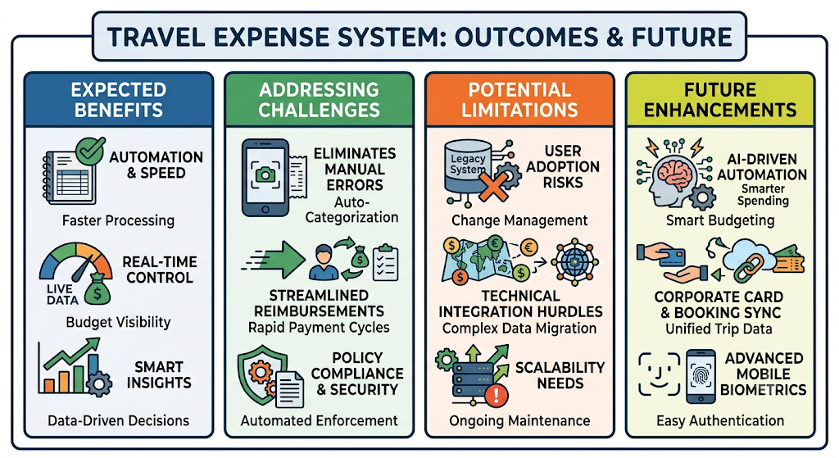
- Ecosystem Expansion: Open APIs to connect seamlessly with additional third-party financial tools and corporate software.

